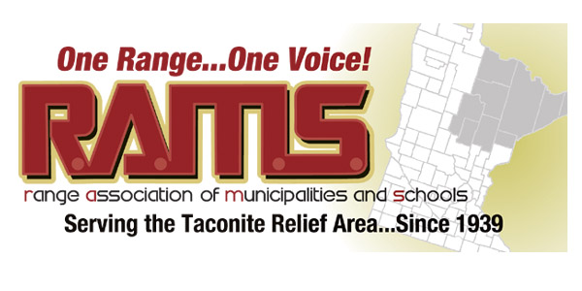

RAMS Resolution 003 – 2018
Iron Range Broadband Resolution

Whereas broadband is an essential service necessary to attract and retain residents and businesses, engage in commerce, obtain equal access to health care and education, and support a modern quality of life;

Whereas our Iron Range communities and particularly our Iron Range rural countryside, include areas that are considered by to be unserved and underserved when using the standards set in Minnesota state statutes;
Whereas the future of the Iron Range is dependent upon a quality Pre-K through 12 education system and educational delivery services are dependent upon high speed, quality broadband;
Whereas any opportunity for economic diversity requires access to gigabit broadband services to afford the Iron Range a competitive chance at attracting new businesses;

Whereas community volunteers in a number of Iron Range communities have completed the hard work to engage citizens via surveys and meetings and to work with broadband planning consultants to gather data and create broadband deployment plans;

Whereas various state and national funding sources are expected to become available;

Whereas, various grant and loan funds require the commitment of a local match to be provided for competitive and successful applications; and

Whereas, funding broadband projects across the Iron Range will require a collaborative effort of townships, cities, St. Louis County and willing telecommunications providers;
Whereas, townships and small cities do not have the staff or expertise to assist with grant applications, joint powers agreements or public/private provider agreements;

Be it Resolved, that the Range Association of Municipalities & Schools (RAMS):
- Supports all efforts to spur the deployment of broadband networks and services that will immediately meet the 2026 state broadband goal of 100 Mb/20 Mb;

- Will support using local financial resources as part of a broadband deployment plan in conjunction with other funding sources;

- Requests that St. Louis County take the lead in developing and finalizing a regional, multi-community approach to spurring broadband deployment, including organizational development, legal requirements and financial planning, direct staff support to our small cities and townships and active participation in potential grant funding applications.

Votes to approve: 15

Votes to oppose: 0

Dave Lislegard – RAMS President October 25, 2018

