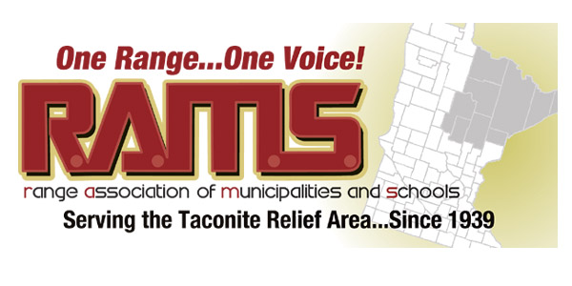

RANGE ASSOCIATION OF MUNICIPALITIES & SCHOOLS
RESOLUTION #2018 – 001

WHEREAS, nonferrous ores contain metals essential to modern daily life – copper, nickel, cobalt, platinum, palladium and gold – found in countless products including cell phones, computers, diabetes test strips, joint replacements, electrical wiring, hybrid cars, catalytic converters and wind turbines; and
WHEREAS, the significant domestic demand for these metals exceeds our national supply due to very few mines in the U.S. producing them, creating an unhealthy imbalance and outside reliance on indispensable raw materials, even with the high rate of recycling (the U.S. currently imports nearly 90 percent of its copper and gold, and only has one small nickel mine); and
WHEREAS, the proposed PolyMet site is located near the community of Hoyt Lakes, within an existing mining district where operating and former iron mines and processing facilities already exist and, with the existing infrastructure in place, the site is viewed as conducive for such an initiative and as stated by our state agencies will clean up legacy issues therefore protecting our region’s environment; and
WHEREAS, the mining industry has for generations supported tens of thousands of families in our region, dozens of communities, schools, commerce and recreation centers, and has created opportunities for scores of children to attend universities and technical schools to develop their own careers and families within the region; and
WHEREAS, the Minnesota Department of Natural Resources and the Minnesota Pollution Control Agency after years of review has determined that the PolyMet NorthMet project meets all regulatory requirements and standards and has released its draft Permit to Mine, water quality permit, Section 401 Certification and air emission permit;

NOW, THEREFORE, BE IT RESOLVED that the Range Association of Municipalities and Schools declares its support for the issuance of state permits and is confident that the exhaustive review by state and Federal regulatory agencies have concluded that the project can be operated in an environmentally safe and secure manner. We support the success of this project for the above stated reasons and believe by meeting Minnesota’s strict environmental standards through a comprehensive environmental permitting process, PolyMet will be poised to play a significant role in contributing to the sustainability of our region’s economy by mining the metals we need every day without harming our region’s air and water quality.

Approved by Board vote Ayes 19 Nays 0
Signed by President

_________________________________________ Dated: __________________________

