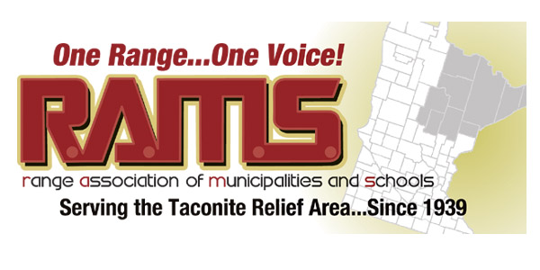

Resolution 05 – 2017
Support for State Funding for Voting Equipment Replacement
WHEREAS, Congress passed the Help America Vote Act (HAVA) in 2002 and provided one-time federal funds to purchase election equipment to all 50 states, and;
WHEREAS, That election equipment, which has a lifespan of 10 to 15 years, is aging and needs to be replaced and the federal government has indicated that it does not intend to provide any additional funds, and;
WHEREAS, a study in Minnesota has determined that it will cost $28 million to replace the election equipment counties originally purchased with HAVA funds and the equipment is at or exceeding its’ expected useable age, and;
WHEREAS, Unlike some responsibilities undertaken by counties and municipalities, administering a statewide election in over 4,000 precincts is not option, it is a statutory requirement and an important part of our democracy, and:
WHEREAS, Given that local governments were caught off guard when the federal funding was not renewed, they need assistance from the state to ensure that voting equipment works properly and consistently in precincts all around the state, and is up to the standards Minnesotans expect, and
WHEREAS, Projected cost for replacement equipment is estimated at $10,000.00 per precinct,
NOW THEREFORE BE IT RESOLVED, the RAMS Board of Directors seven (7) counties, 47 public sector communities, townships and all public school districts in the Taconite Assistance Area, heretofore support Governor Dayton’s proposal for $14 million dollars of state funding to assist counties, communities and school districts with financial support for the systematic replacement of the aging election equipment, and
BE IT FURTHER RESOLVED, the RAMS Board of Directors supports the efforts of Secretary of State, Steve Simon in his pursuit of funding via legislative action during the 2017 legislative session in recognition of the hardship the purchase of replacement voting equipment will place on many rural communities across the State of Minnesota.
On Behalf of the RAMS Board of Directors,
___________________________________ Dated: February 23, 2017
Paul Kess, President RAMS
Approved on a vote of 19 ayes 0 nays

