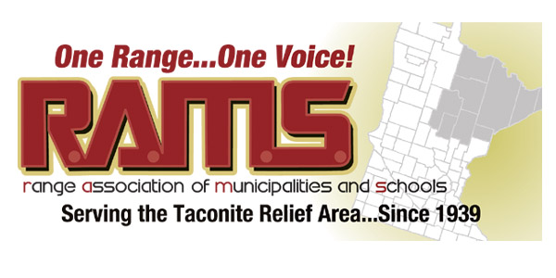

Resolution 06 – 2017
Support for Laurentian Energy Authority (LEA) Legislation

Whereas, the Hibbing and Virginia Public Utilities have delivered reliable electric, steam, and gas utilities for their residents and businesses for over one hundred years; and

Whereas, the communities have invested capital resources for generations to upgrade and modernize these utilities; and

Whereas, the employees of the two public utilities have proudly and efficiently provided these needed services to their neighbors and their jobs are an important economic driver in the communities of Hibbing and Virginia; and

Whereas, in 2005, the two public utilities formed the innovative Laurentian Energy Authority (LEA), which invested $86 million to add renewable biomass energy to their portfolio of generation; and

Whereas, the LEA has developed a long-term contract with the state’s largest utility, Xcel Energy, and has sold for ten years reliable, renewable electric power under a long-term contract; and

Whereas, the LEA is now seeking changes to allow LEA to lower its risk profile by changing its biomass requirements by reasonable modification, thereby reducing financing risks for its citizens, and is seeking a an extended contract with Xcel Energy in order to further secure its future for the citizens of Hibbing and Virginia;

Therefore Be It Resolved, that the Range Association of Municipalities and Schools strongly supports its members, the Hibbing Public Utilities and the Virginia Public Utilities and the Laurentian Energy Authority, in their efforts to secure their future by encouraging the Minnesota Legislature and the Governor to pass and enact into law Senate File 700 and House File 759.

On behalf of RAMS Board of Directors,
_______________________________ Dated: Feb 23, 2017
Paul Kess, President
Approved on a vote of ______ ayes _____ nayes

Points:

- LEA has ten years remaining on its contract with Xcel Energy. By seeking an extension, LEA will preserve the jobs at the public utilities.
- With an extension, LEA will be able to continue bring revenues to the public utilities to invest over the long term in repairing steam lines in the cities.
- By slightly lowering the required biomass percentage from 75% average over 20 years for generation, LEA will lower or eliminate the risk of a potential $10 million penalty payment in 2027.

