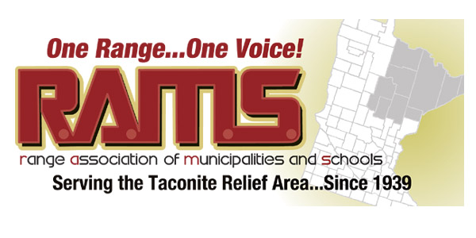

RESOLUTION 04 – 2017
SUPPORT FOR MESABI METALLICS
WHEREAS, the leadership team for the former Essar MN mine project has now been taken over by CEO, Matthew Stock, and
WHEREAS, Essar Global, Essar MN, and any subsidiary of Essar has been completely removed from the project, and
WHEREAS, the newly named company, Mesabi Metallics, recognizes the long term viability and sustainability of this project, including “value added” components, and
WHEREAS, the project sits on the largest deposit of low silica ore found across the Iron Range with nearly 1 billion tons of ore, and
WHEREAS, the leadership of Mesabi Metallics have taken the time to foster and develop new markets for their products that will have no impact on any other Range mine operation, and
WHEREAS, upon completion this will be the largest single private development in the State of Minnesota at over $2.1 billion dollars of investment, and
WHEREAS, the mine will employ 350 workers who will have the unfettered right to join a union of their choosing and will have long term employment with a 75 year ore deposit;
THEREFORE BE IT RESOLVED, the Range Association of Municipalities & Schools by passage of this resolution goes on record in strong support for the new leadership at Mesabi Metallics and the completion of this much needed mining project on the Western Iron Range that will open new markets for Range steel and reduce our dependence on foreign steel imports while providing a long lasting and significant economic impact to our region and the State of Minnesota.

On Behalf of RAMS Board of Directors:
Paul Kess/President Dated: January 26, 2017
Approved on a vote of 22 ayes; 0 nays

