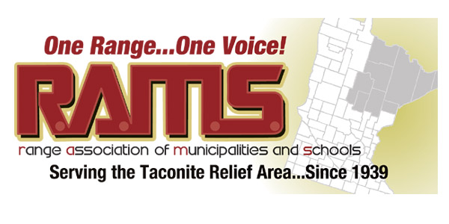

Resolution 03 – 2017
Support for Trustee Appointment
WHEREAS, Paul Kess, president elect of the Range Association of Municipalities & Schools (RAMS) has proven his leadership style and ability, and
WHEREAS, Paul Kess, has served as an elected public official for over 10 years on the Ely City Council and was re-elected as the top vote recipient in the 2016 elections, and
WHEREAS, Paul Kess has over 35 years of teaching experience having just retired from the Vermilion Community College in Ely which is a campus of the MNSCU (Minnesota State) system, and
WHEREAS, the fellow members of the RAMS board of directors desire to show their support and respect for Paul Kess and his desire to serve as a trustee for Minnesota State Board,
THEREFORE BE IT RESOLVED, the RAMS board of directors by a unanimous vote of support, hereby soundly recommend to Governor Dayton our earnest support for Paul Kess and respectfully ask for your sincere consideration of his appointment to the board of trustees for Minnesota State.
On Behalf of the RAMS Board of Directors:
Pat Medure, Secretary/Treasurer Dated: January 26, 2017

Approved on a vote of 22 ayes; 0 nays

