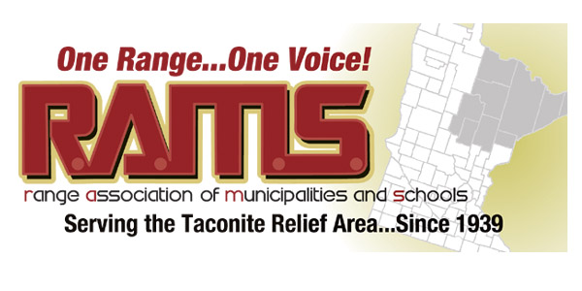

IRON RANGE REGIONAL RAIL RESOLUTION – 001 - 17
WHEREAS, the State of Minnesota is served by four major Class 1 railroads, BNSF Railway (BSNF); Canadian National (CN); Canadian Pacific (CP); and Union Pacific (UP), rail users on the state’s Iron Range have access only to the BNSF and CN lines, and
WHEREAS, within the Iron Range customer base, rail connections in general, are only available by one of the two Class 1 railroads thereby resulted in a “captive shipper status” for businesses that can only transport their goods with one rail company, and
WHEREAS, lack of competitive rail and the necessary infrastructure to support the growing demand for rail access and use has resulted in congestion, reduced quality of service and increasing prices to the users and limits economic growth, and
WHEREAS, on the Iron Range rail access is critically important to our mining industry, power suppliers, ancillary mining industries and timber and paper mills, limited access can result in loss of productivity, increased production costs, additional power cost passed on to consumers and significant limitations on shipping of products, and
WHEREAS, the 2015 Minnesota State Rail Plan identifies as a specific goal; “To maintain and ensure broad access to competitive freight rail services for shippers throughout the state”;
THEREFORE BE IT RESOLVED, that the RAMS board of Directors heretofore goes on record in support of the regional rail initiative also known as the “West Range Connector Project” and the “Central & East Range Industrial User Access Project” and that associated grant and legislative funding request that are necessary to bring these projects forth so that all businesses may experience better, affordable, rail access from multiple suppliers.
On Behalf of RAMS Board of Directors:

Paul Kess/President RAMS Dated: January 26, 2017
Passed on a vote of 22ayes; 0 nays

